Interim Progress Report
Energy-Aware Cloud Resource Infrastructure Simulator

Name:

Student ID:

Course ID:

Supervisor:

Date: July 20, 2026

Contents
Interim Progress Report 1
Abstract 3
1. Introduction 4
1.1 Background 4
1.2 Aim and Objectives 4
1.3 Justification & Significance of Study 5
2. Related Works and Literature Review 6
2.1 Foundational Heuristics and Simulation Toolkits 6
2.2 Recent Advancements and the Shift Toward Machine Learning (2024–2025) 6
2.3 Discussion on Tools and Concepts Used 7
3. Methodology 8
3.1 Design Components 8
3.2 Design Considerations and Progress 8
4. Project Plan & Ethical Considerations 9
4.1 Project Plan and Current Progress 9
4.2 Consideration of Ethical, Legal, Professional, and Social Issues 11
4.3 Gantt Chart 12
5. Reference List 13

Abstract
This project aims at solving the critical issue of non-linear power scaling and energy inefficiencies in the current cloud data center by designing a simulator which models energy-aware cloud resources. Current green computing models choose to sacrifice substantial losses to the system throughput to realize energy savings. The objective of this research is to demonstrate that dynamic, rule-based VM scheduling heuristics can optimize power usage at peak loads while respecting Service Level Agreements (SLAs). This involves developing a pipeline for general discrete event simulations in Python (using SimPy), running theoretical workloads and implementing a custom Rule Based Constraint Engine. The expected result is a proven scheduling heuristic that gives practicable guidelines for resource allocation that significantly lower carbon footprints for cloud infrastructures, without compromising task completion latency.

1. Introduction

1.1 Background

Energy efficiency is a growing problem at modern cloud data centers. One cause is non-linear power scaling; as you near maximum load on the server (95% of the time, for example), there are inefficiencies in the heat that is generated, and there's cooling requirements involved as well. Existing policies for dynamic task-scheduling (such as Round-Robbin) cannot overcome these dynamic bursts in load, while state-of-the-art models of dynamic task-scheduling sacrifice performance for power-efficiency. A deterministic scheduling model is needed to optimise the trade-offs between these constraints.

1.2 Aim and Objectives
The general objective of this research is to model workloads for cloud data centre for energy efficiency studies and to build dynamic resource scheduling models that can practically yield optimum scheduling decisions to schedule VMs in cloud data centre based on theoretical energy load.
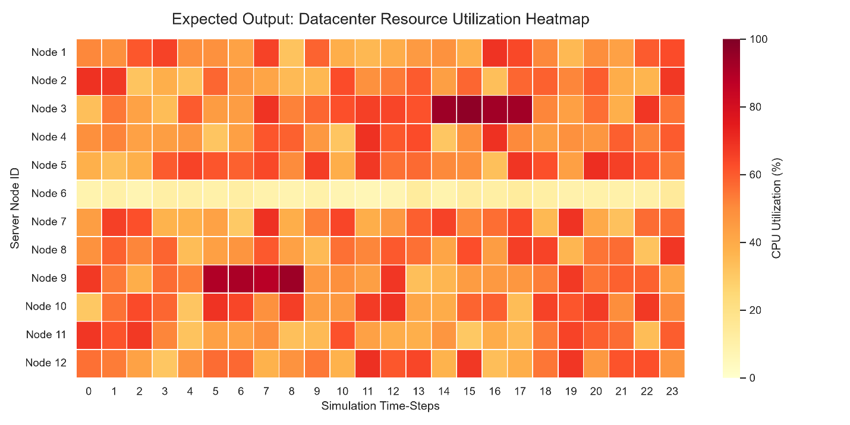
Figure 1: A preliminary mock-up demonstrating the expected output format. The final simulation will generate actual utilization data tracking CPU load across multiple nodes.
Objectives:
- To develop mathematical data templates using vectorized arrays for mapping a percentage of theoretical CPU load to power variables (kWh) of hardware.
- To create a complete discrete-event simulation "backend loop" that runs the time-step simulation of workload distributions on multi-core server nodes.
- To develop and embed an optimisation system with a "multi-layered" "if/else" constraint engine that dynamically redistributes execution tasks.
- Measure, extract, and compare the total energy cost of execution and the time to completion of tasks with the baseline static schedulers.
- To create resource utilization heat maps and throughput logs reconciling the backend information and apply it to your infrastructure's improvements.

1.3 Justification & Significance of Study

Data centers have a huge footprint, and cloud infrastructure is responsible for a significant share of the total electricity use in the world today. Power savings of megawatts per facility per year can be realized by optimizing workloads on the servers. This study is motivated by its new deterministic scheduling for the goal of prioritising zero throughput degradation with a goal of targeting peak-power anomalies. This work offers easy-to-implement, actionable resource allocation guidelines to help IT stakeholders lower their facility's carbon footprint and reducing their operational costs without impacting their user experience.

2. Related Works and Literature Review

2.1 Foundational Heuristics and Simulation Toolkits
Buyya et al. (2010) introduced the vision of using computing as a utility, which ultimately became the baseline needs for a modern infrastructure management such as cloud computing. On top of this, optimization of the use of the resources to achieve energy efficiency became a major area of research.
One of the benchmark papers in the area is that of Beloglazov et al. (2012) that introduces energy-aware resource allocation heuristics with a strong VM consolidation bias. This approach is able to detect idle servers, consolidate the currently running VMs onto a smaller number of hosts, and shut down the idle servers. A major weakness of this technique is accepting a reduction of performance. Because of the latency associated with live migrations, aggressive VM consolidation often results in breaches of Service Level Agreements (SLA). The proposed project will fill this exact niche by changing the focus from consolidation to deterministic/mill-accurate load balancing by adding a "Strict SLA Migration Lock.
Such heuristics need strong simulations to be validated. Cloud environments were modeled by many researchers such as Calheiros et al. (2011) whose toolkit was called CloudSim. CloudSim offers good built-in infrastructure models but to create a custom mathematical array and adapt its Java-based system to rapid prototyping is stiff. This project therefore uses a new coded version of the discrete event simulation for easier integration with new data-science tools versus CloudSim.

2.2 Recent Advancements and the Shift Toward Machine Learning (2024–2025)
Based on the studies conducted in the past, this need for energy-aware VM consolidation has been identified, and recent research from 2024 and 2025 documents an industry transition to problem-complexity oriented optimization based on prediction.
In recent research (Nuthalapati 2024), Nuthalapati stresses that reactive resource provisioning is challenging under strict Service Level Agreement (SLA) constraints, often resulting in over-provisioning of resources in the form of servers. To overcome this, modern architectures now generally utilize machine learning (ML) and reinforcement learning (RL) techniques to forecast workloads. Likewise, carbon-aware placement research like the Deep Q-Networks (DQNs) strive to ensure that both economic sustainability goals and SLA performance are met by learning to identify traffic patterns from past interactions with the environment (Iqbal et al., 2025).
In addition, a recent paper in IEEE Transactions on Sustainable Computing (2025), shows that current consolidation approaches are flawed: overly dense VM packs leads to extreme "hot spots," affecting hardware reliability and thus costing a lot of cooling energy to counter that initial savings. In order to overcome this, researchers have been trying out complicated meta-heuristics such as Blended GA & Simulated Annealing, which monitor server temperatures and initiate dynamic migrations.
Gap Identification and Project Contribution:
The recent trend of literature focuses mainly on the calculation intensive use of AI models and workload forecasting, creating a noticeable difference. Emerging articles in the field of green software architecture claim that reducing CO2 through workload predictions are not always successful due to the instability of traffic in dynamic cloud environments.
This project tackles this very drawback. This research presents an alternative approach to depend on the heavy machine learning models that requires a lot of training data, by using a lightweight, deterministic, Rule Based Constraint Engine. This provides the immediate advantages of dynamic VM scheduling without the computational advantage of AI and with a hard SLA-lock, making it extremely practical for real-time infrastructure management.

2.3 Discussion on Tools and Concepts Used
The project is based on Discrete-Event Simulation (DES) methodology. Whereas continuous simulation models the behavior of a given system as a continuous stream of events over time, with days of data centre traffic being calculated in mere minutes of simulation time, DES models a system as a sequence of discrete events over time. For this purpose, the SimPy framework is used together with NumPy for vectorized mathematical power coefficient calculation, creating a very flexible and Pythonic evaluation environment.

3. Methodology

3.1 Design Components
It is divided into three major system components:
- Workload Generator: Generates random traffic at data centers (low traffic during the day, high traffic during load spikes).
- The SimPy Environment Engine: controls the time-steps, server nodes, and VM resources.
- The Rule-Based Constraint Engine: Custom routing logic that executes before tasks are assigned to the server when checking server power states.

3.2 Design Considerations and Progress
A custom Python pipeline was chosen to build over CloudSim because seamless data analysis was required. The data extraction (using Pandas) and visualization (using Matplotlib/Seaborn) is conveniently performed as part of the simulation program to eliminate workflow bottlenecking.
The Rule Based Constraint Engine is currently in development. It is based on three fundamental design decisions made to avoid the weaknesses of current models:
- The Power Sweet Spot: Prevent heat penalties by limiting server allocations when servers are running at greater than 85% CPU utilization.
- The Anti-Thrashing Filter: A temporal filter to suppress micro-bursts in the CPU for less than 3 simulation time-steps, avoiding unnecessary VM migrations for such short periods.
- The SLA Lock: An energy-saving migration hard limit that aborts migrations if compute time to migrate the VM exceeds the latency limit of the task.

4. Project Plan & Ethical Considerations

4.1 Project Plan and Current Progress
The creation of a realistic simulator from scratch demands a careful step-by-step procedure. A thorough research effort has been put in early stages of the project, with a focus on building a foundational space application project.
Current Progress: The Mathematical Foundation
Right now, the main emphasis has been directed towards mathematical research. Now we must establish the "physics" of a data center before a successful image of it can be created. This has included studying dynamic power coefficients, thermal penalty curves, and also defining the exact mathematical formula that describes the exponential increases in the server's power usage as CPU utilization approaches 100% (shown in Figure 2).
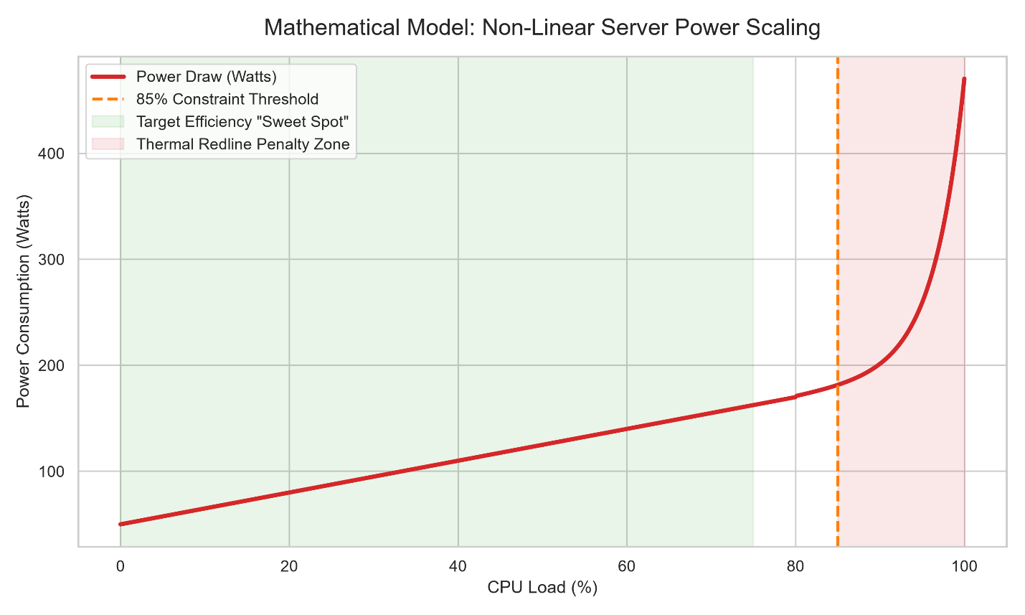
Figure 2: Mathematical model visualizing the exponential "Redline Penalty" applied when simulated CPU load exceeds the 85% threshold.
These formulas are in progress to be translated to vectorized NumPy arrays. Having this mathematical foundation firmly connected and confirmed to theoretical requirements first, we can guarantee the simulators' eventual outcome will reflect real-world hardware. As these power models are nearing completion, the project is now in the process of moving from theory to practice in terms of software development.
Planning the Development Phase
The next step would be to create a decoupled, layered assembly for stability. Rather than trying to program the entire environment all at once, the development is outlined below:
- The "Dumb" Baseline: We first create a minimal version of the SimPy clock and server resources. This environment acts as a control group, where the processes are queued and acted upon with a blind, static scheduler (such as Round-Robin).
- The "Brain" Injection: Once the baseline loop is stable and bug-free, we will develop and add the custom Rule Based Constraint Engine.
- Comparative Analysis: Using identical workload arrays for both "dumb" workloads and intelligent workloads, we will be able to see exactly what differences in the total energy consumed (kWh) and the amount of time to complete a task are presented.
The project has been broken up in to six separate tasks, while keeping development on track for completion within the 12 weeks. The basic mathematical modeling is almost finished, and the baseline SimPy environment and the creation of the data arrays is underway. Individual tasks and their expected timeframe (in weeks) and current completion status are provided in the table below:

Task ID | Task Description | Timeline | Status
Task 1 | Literature Review & Mathematical Power Modeling | Weeks 1 - 3 | Completed
Task 2 | Setup Baseline SimPy Environment & Data Generation | Weeks 4 - 5 | In Progress
Task 3 | Code the Dynamic "Green Heuristics" Constraint Engine | Weeks 6 - 8 | Pending
Task 4 | Simulation Execution & Backend Data Extraction | Weeks 9 - 10 | Pending
Task 5 | Data Visualization (Heatmaps/Charts) & Analysis | Week 11 | Pending
Task 6 | Final Report Writing and Formatting | Week 12 | Pending

4.2 Consideration of Ethical, Legal, Professional, and Social Issues
The deployment and development of this Energy-Aware Cloud Resource Infrastructure Simulator have a number of implications, including those displayed by the BCS Code of Conduct for Computer Science Research.

Ethical Issues:
One of the main ethics of this study is the responsibility for the environment. Cloud computing consumes a significant share of the global electricity generated and is expected to see even larger share of power in the future. This project plays an active role in sustaining development and responsibly reducing the use of energy and thus the ecological impact of digital infrastructure by actively developing heuristics that reduce the energy waste without negatively impacting system performance. Additionally, the project is built solely on mathematical simulation or MDC (deliberately designed workload arrays) and no real user data is used, eliminating potential ethical concerns over data privacy and human subjects.

Legal Issues:
The data used in this simulation is synthetic; however, when moving these heuristics from simulation to real-world deployment, it is critical these comply with legal obligations regarding data privacy (e.g. GDPR in the UK/EU). Future implementations should guarantee that the "Rule Based Constraint Engine" does not inadvertently capture, log or reveal packet data that might be sensitive to the VM migration process. Further, the software written in this project will adhere strictly to the permissions of licenses awarded for the Python libraries used as open-source software resources (SimPy, Pandas) if the final software repository is published.

Professional Issue:
The scheduling heuristics are critical from a professional perspective, and it is important to guarantee their absolute integrity and not misrepresent them. As outlined in professional IT codes of conduct, there is a duty to avoid causing harm or disruption to a client's business. So, the "Strict SLA Migration Lock" should be a convergence necessity into the algorithm. It ensures that actions taken to save energy will never take place if the Service Level Agreement (SLA) for latency and throughput is breached, so keeping professionals stakeholders' expectation of operational reliability.

Social Issue:
The social relevance of this research is having to look at the global requirements for carbon reductions and the societal demand for immediate digital services (streaming, AI processing, cloud storage). This project provides open-source, application-friendly rules for resource allocation, and seeks to open up the use of green computing techniques. It gives smaller IT organisations and educational institutions deterministic means to operate their data centres with less impact and costs, enabling a more equitable and environmentally friendly technological society.

4.3 Gantt Chart
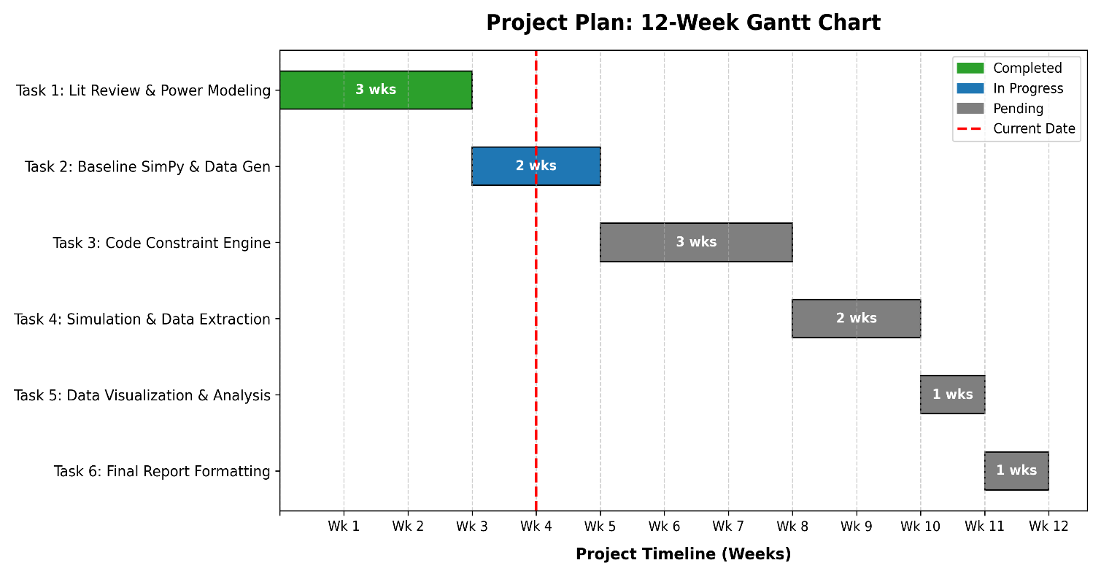

5. Reference List
Beloglazov, A., Abawajy, J. and Buyya, R. (2012) 'Energy-aware resource allocation heuristics for efficient management of data centers for cloud computing', Future Generation Computer Systems, 28(5), pp. 755-768.

Buyya, R., Yeo, C.S., Venugopal, S., Broberg, J. and Brandic, I. (2010) 'Cloud computing and emerging IT platforms: Vision, hype, and reality for delivering computing as the 5th utility', Future Generation Computer Systems, 25(6), pp. 599-616.

Calheiros, R.N., Ranjan, R., Beloglazov, A., De Rose, C.A. and Buyya, R. (2011) 'CloudSim: a toolkit for modeling and simulation of cloud computing environments and evaluation of resource provisioning algorithms', Software: Practice and Experience, 41(1), pp. 23-50.

IEEE Transactions on Sustainable Computing (2025) 'An Energy-Aware Virtual Machine Scheduling Approach for Cloud Data Centers', IEEE Transactions on Sustainable Computing, (Issue 2025.05).

Iqbal, M. et al. (2025) 'Carbon-Aware, Energy-Efficient, and SLA-Compliant Virtual Machine Placement in Cloud Data Centers Using Deep Q-Networks and Agglomerative Clustering', ResearchGate Preprint.

Nuthalapati, A. (2024) 'Cloud data center performance optimization through machine learning-based workload forecasting and energy efficiency', International Journal of Science and Research Archive, 13(2), pp. 2353-2361.

